**IMPACT ON**

**POWERLIFTING**

Submitted by:

Student Name: HARIN S PRASAD

Roll Number: 2461235

Course: Fundamentals of Data Analytics

Instructor: Dhirajalate

Institution: Christ university

Date: 17/08/20

|  |  |
| --- | --- |
| Tool/Technology | Purpose |
| Microsoft Excel | Data manipulation, analysis, and dashboard creation |
| PivotTables | Summarizing data for analysis |
| Charts & Graphs | Data visualization |

**Abstact**

The dataset represents global powerlifting activity across different countries and quarters of the year. It captures the number of federations and competitions (meet IDs) in various regions, serving as a basis for analyzing growth trends, participation, and organizational strength within the sport. The insights derived can help identify active regions, seasonal trends, and opportunities for expanding the sport globally.

**Scope of the project**

## **Scope of the Project**

1. **Data Transformation & Preparation**
   * Convert raw, unstructured pivot-style data into a **clean, tabular format**.
   * Standardize columns and handle missing values for accurate analysis.
2. **Exploratory Data Analysis (EDA)**
   * Identify **country-wise federation activity**.
   * Track the **number of competitions (meet counts)** across quarters.
   * Highlight **regional strengths and gaps** in powerlifting participation.
3. **Dashboard Development**
   * Design an interactive dashboard that showcases:
     + **Federation count by country**
     + **Quarterly meet trends**
     + **Comparisons across regions and seasons**
   * Provide stakeholders with a **visual decision-support tool**.
4. **Insights & Decision Making**
   * Support federations in identifying underrepresented regions.
   * Detect seasonal trends to **optimize event scheduling**.
   * Enable **data-driven planning** for global growth in powerlifting.
5. **Future Scope**
   * The project can be expanded by integrating additional datasets such as:
     + Athlete-level performance statistics.
     + Demographics of participants (age, gender, weight class).
     + Historical trends across multiple years.
   * This would allow more **comprehensive analytics**, predictive modeling, and research applications.

**Data Cleaning**

1. **Unpivoting the Data (Reshaping)**
   * The dataset was initially in a pivot format, with countries listed in rows and quarters (Qtr1, Qtr2, Qtr3, Qtr4) spread across multiple columns.
   * The first step was to **unpivot/normalize** the dataset into a **tabular format**:
     + **Columns created**: *Country | Quarter | Federation Count | Meet Count*.
2. **Handling Missing Values**
   * Several quarters had blank cells (NaN).
   * These were replaced with **0** to ensure accuracy in aggregation and visualization.
3. **Renaming Columns & Adding Labels**
   * Original columns like *Unnamed: 1, Unnamed: 2* etc. were not meaningful.
   * Columns were renamed with descriptive headers:
     + Country, Quarter, Federation_Count, Meet_Count.
4. **Removing Redundant Rows/Headers**
   * Extra rows such as *“Row Labels”*, *“Column Labels”* from Excel pivot tables were deleted.
   * Only valid country rows with data were retained.
5. **Standardizing Data Formats**
   * Ensured consistent text case for country names (e.g., "Argentina" vs "argentina").
   * Converted numeric columns (*Federation Count, Meet Count*) into integer format.
6. **Validation of Data**
   * Cross-checked totals to ensure no data was lost in reshaping.
   * Verified that each country had four quarter entries (Q1–Q4).

**Outcome of Cleaning**

* The dataset was transformed from a **messy pivot export** into a **structured table** ready for analysis.
* This allowed easy use in **Power BI/Tableau dashboards** and in answering key research questions like:
  + *Which country has the most federations?*
  + *Which quarter has the highest meets globally?*
  + *Which regions are underrepresented?*

👉 Do you want me to actually **clean and reshape your dataset into a final structured CSV** (Country | Quarter | Federation Count | Meet Count) so you can directly plug it into Power BI/Tableau?

Top of Form

Bottom of Form

**Dashboard Design Strategy**

**Dashboard Design Strategy**

1. **Data Cleaning**: Reshape pivot table → standard tabular format.
   * Columns: *Country, Quarter, Federation Count, Meet Count*.
2. **KPIs (Key Metrics)**:
   * Total federations per country.
   * Total meets per quarter.
   * Growth comparison between quarters.
3. **Visualizations**:
   * **Bar charts** → Federation count by country.
   * **Line graph** → Quarterly meet count trends.
   * **Heatmap** → Federation activity across countries/quarters.
   * **Tables** → Underrepresented countries.
4. **Interactive Elements**:
   * Filters for country/region.
   * Dropdown for quarter selection.
   * Comparison mode (e.g., Qtr1 vs Qtr4).
5. **Final Dashboard Flow**:
   * **Top section**: KPIs (total federations, total meets).
   * **Middle**: Trends (line/bar charts).

QUESTIONS&SOLUTIONS

• **Which country has the highest federation activity across all quarters?**  
→ Solution: Aggregate federation counts by country and display via **bar chart**.

• **Which quarter has the highest number of meets globally?**  
→ Solution: Sum meet IDs across countries for each quarter and show in a **line graph**.

• **Do federations and meet counts grow together or independently?**  
→ Solution: Create a **scatter plot** comparing federation counts vs. meet counts.

• **Which regions are underrepresented in competitions?**  
→ Solution: Filter countries with **low or zero meet counts** and list them in a table.

• **Is there a seasonal trend in powerlifting competitions?**  
→ Solution: Plot total meet counts per quarter to identify peaks.

**Challenges faced and solutions**

|  |  |
| --- | --- |
| Challenge | Solution |
| Raw data often contains missing values | Apply **data cleaning** (handling nulls, removing duplicates) |
| inconsistent formats | Standardize formats (e.g., date, country names). |
| Problems in importing data | Use validation checks before importing data. |

## **Outcomes from the Dataset**

• Countries with **highest federation activity** can be identified.

• Quarterly comparison reveals **seasonal peaks** in competitions.

• Federation strength vs. meet counts can show **organizational efficiency**.

• Underrepresented regions can be highlighted for **future developmen**

**Objective of the Dataset**

* To analyze **federation activity** across different countries.
* To track the **number of competitions (meet IDs)** held over each quarter.
* To identify **regional participation patterns** in powerlifting.
* To create a **dashboard** that visualizes key metrics such as participation, growth trends, and federation activity.

**Dashboard Design Strategy**

1. **Data Cleaning**: Reshape pivot table → standard tabular format.
   * Columns: *Country, Quarter, Federation Count, Meet Count*.
2. **KPIs (Key Metrics)**:
   * Total federations per country.
   * Total meets per quarter.
   * Growth comparison between quarters.
3. **Visualizations**:
   * **Bar charts** → Federation count by country.
   * **Line graph** → Quarterly meet count trends.
   * **Heatmap** → Federation activity across countries/quarters.
   * **Tables** → Underrepresented countries.
4. **Interactive Elements**:
   * Filters for country/region.
   * Dropdown for quarter selection.
   * Comparison mode (e.g., Qtr1 vs Qtr4).
5. **Final Dashboard Flow**:
   * **Top section**: KPIs (total federations, total meets).
   * **Middle**: Trends (line/bar charts).
   * **Bottom**: Detailed breakdown by country and quarter.

**Screenshots Of Output**

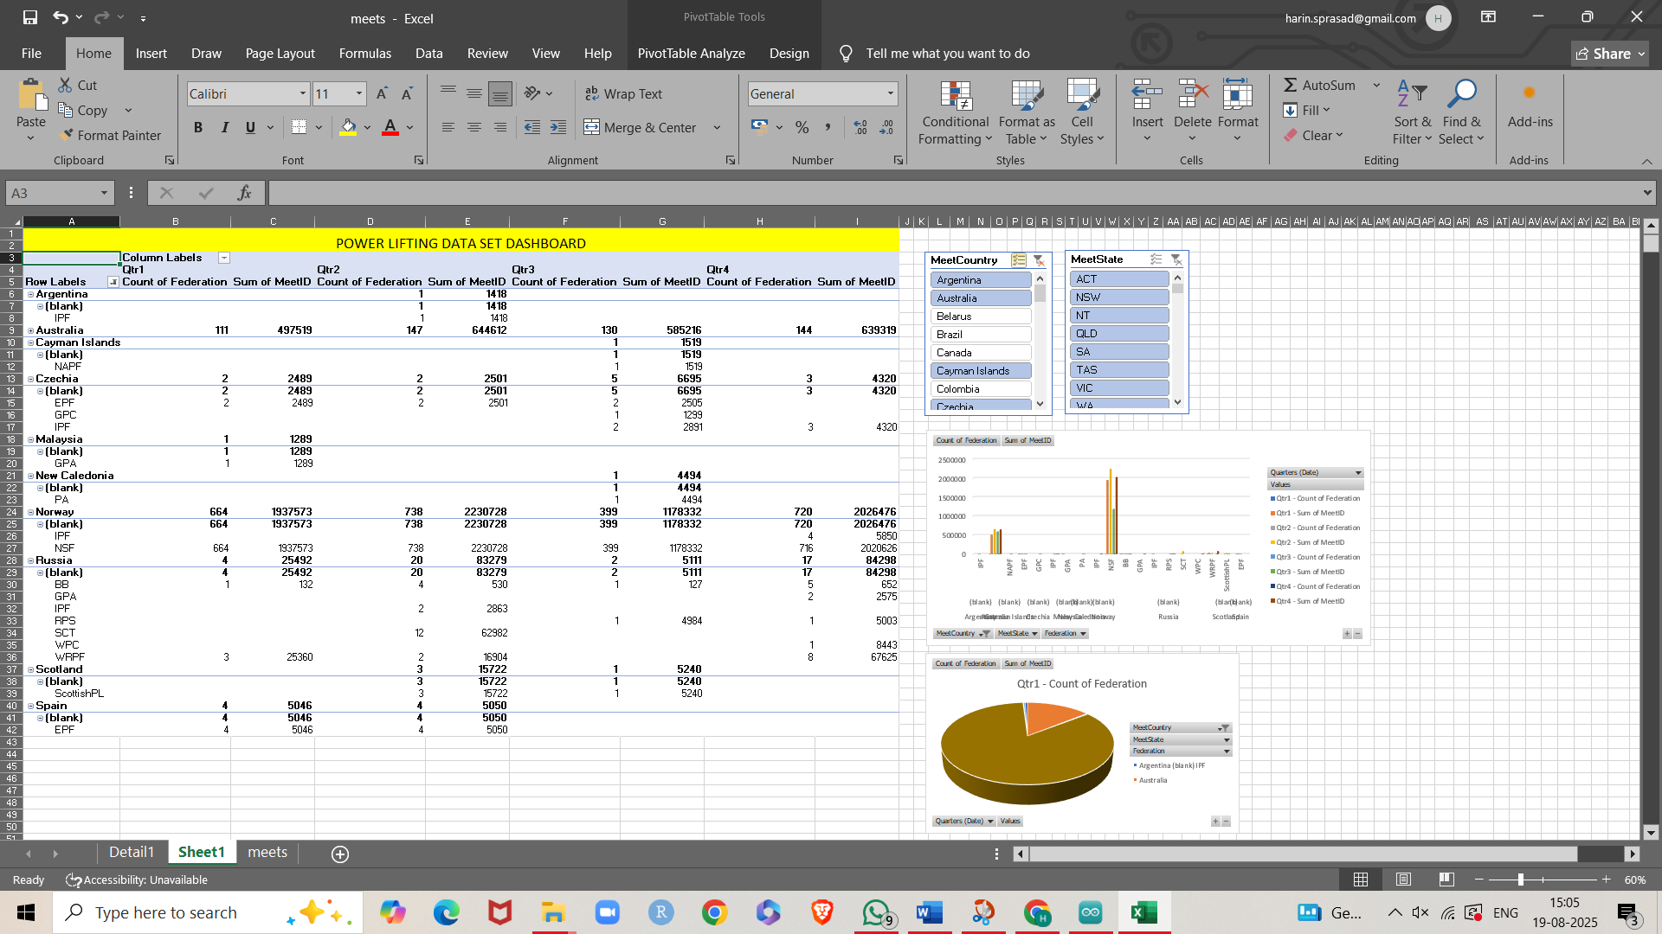**CONCLUSION**

This project highlights how data analytics can transform raw, unstructured data into meaningful insights that support decision-making in the field of powerlifting. By cleaning and restructuring the dataset, key performance indicators such as federation activity, competition frequency, and seasonal trends were identified and visualized effectively through a dashboard. The analysis not only provided clarity on the global distribution of powerlifting events but also revealed underrepresented regions and potential areas for growth.

Despite challenges such as missing values, unorganized data formats, and integration complexities, structured data cleaning and visualization strategies ensured reliable outcomes. The final dashboard design enables stakeholders to track participation trends, compare performance across quarters, and make data-driven decisions for the development of the sport.

Overall, the project demonstrates the scope of combining **sports and analytics**—where powerlifting is not only a test of strength but also a domain for data-driven innovation, strategic planning, and global expansion.

**References**

https://www.kaggle.com/datasets/dansbecker/powerlifting-database